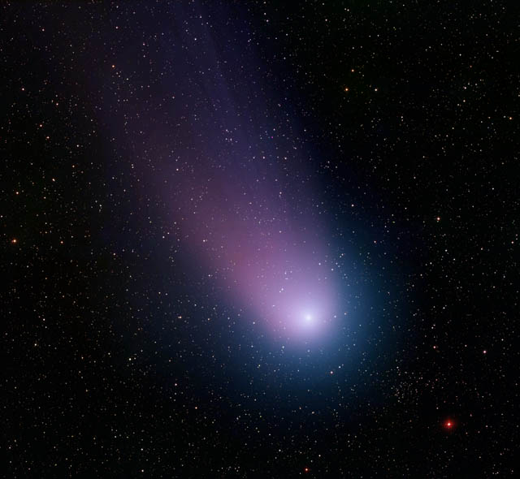Astronomy!

It’ll take you

out of

this world!

April is Global Astronomy Month

Global Astronomy Month (GAM), organized each April by Astronomers Without Borders, is the world’s largest global celebration of astronomy. Every year GAM brings new ideas and new opportunities, bringing enthusiasts together worldwide to celebrate Astronomers Without Borders’ motto

ONE PEOPLE, ONE SKY

<http://astronomerswithoutborders.org/>